Task 1: Create an S3 Bucket and Upload Some Objects

Objective
Learn how to create an S3 bucket and store files inside it.

Prerequisites
- AWS Account
- IAM User with S3 Full Access
- AWS Management Console access

Implementation Steps

Step 1: Open S3
- Login to AWS Console
- Search S3
- Click Create bucket
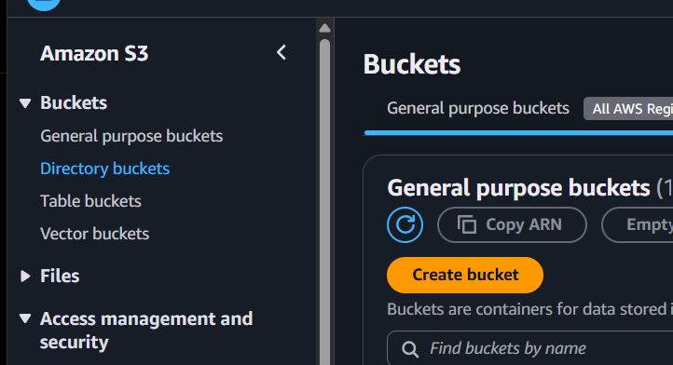

Step 2: Create Bucket
- Bucket Name: nikhil-demo-bucket-001 (must be globally unique)
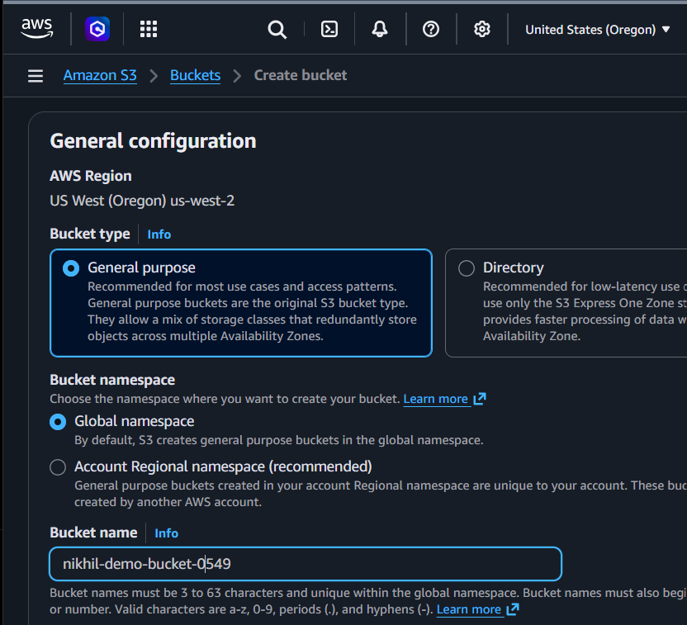
- Region: Choose your preferred region
- Keep Block Public Access enabled
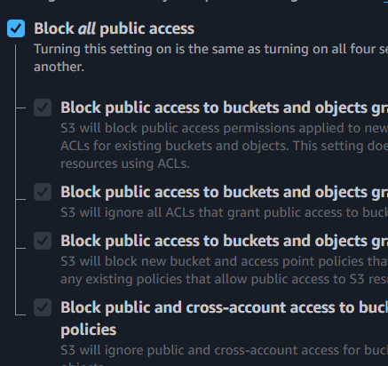
- Click Create bucket

Step 3: Upload Files
Open bucket
Click Upload
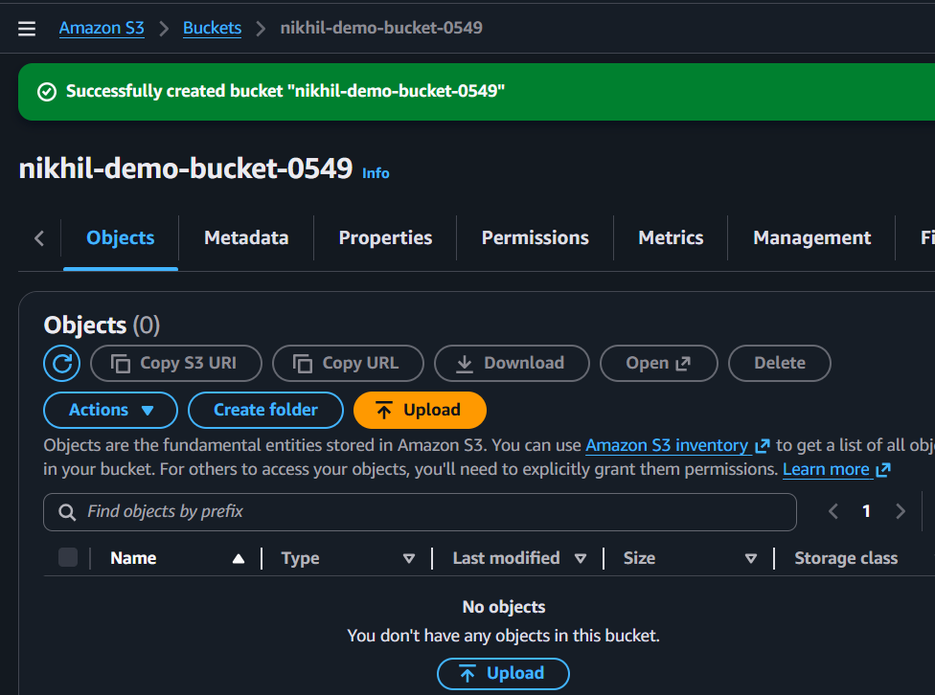
Add files such as:
- image.jpg
- notes.txt
- sample.pdf
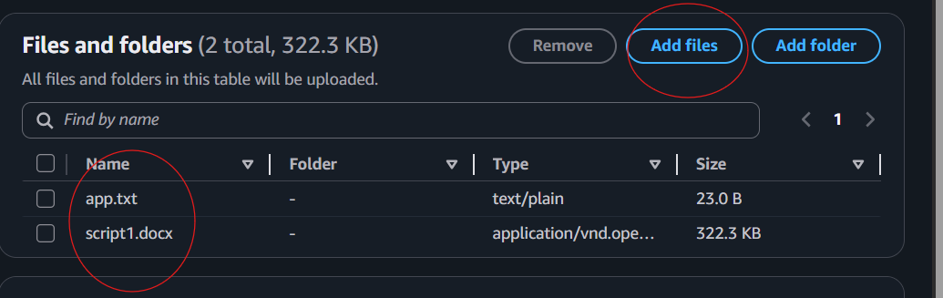
Click Upload
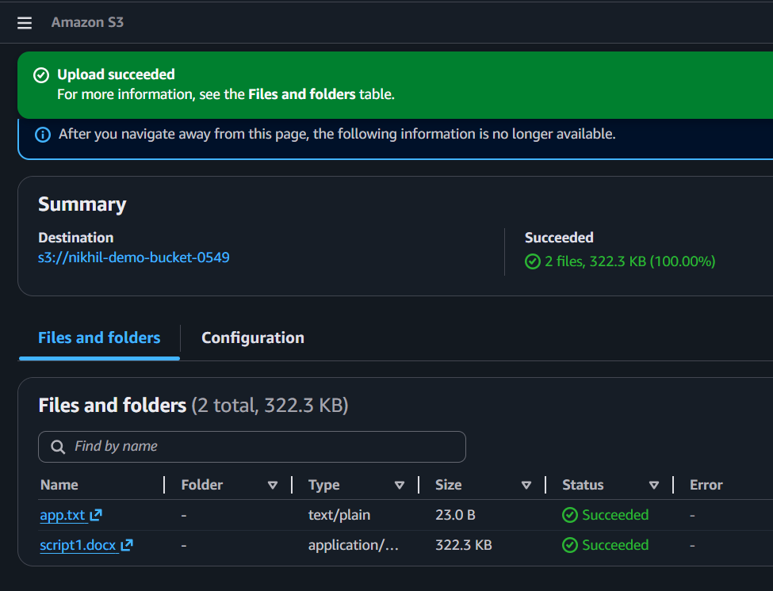

Validation
Open the bucket.
Verify:
- Bucket exists.
- Uploaded objects are visible.
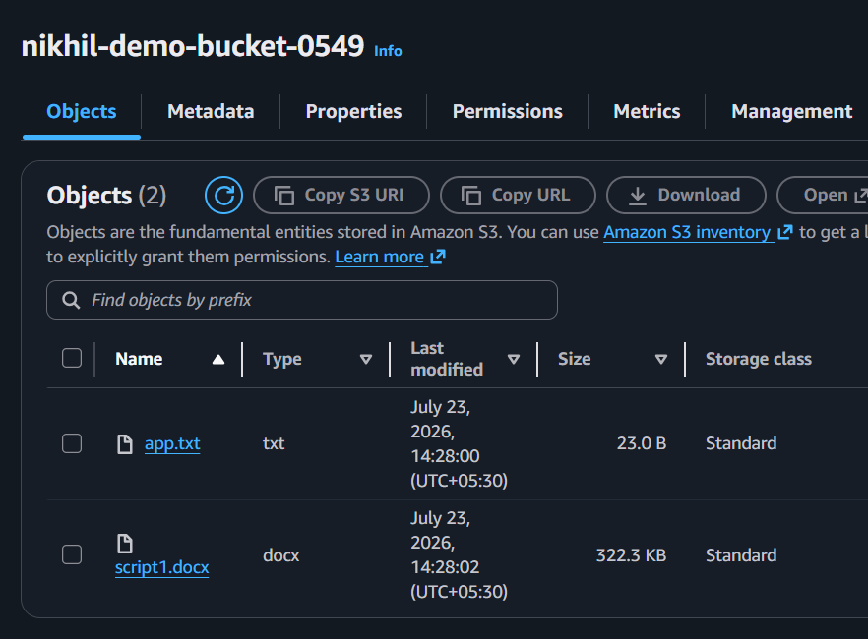
- Click any object.
- Download it.
- Open the file successfully.
Expected Result:
Bucket Created Successfully

Task 2: Deploy a Static Website in S3

Objective
Host a static HTML website using S3.

Prerequisites
- Existing S3 bucket
- index.html
- error.html

Implementation Steps

Step 1
Create files
index.html
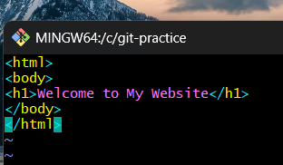
error.html
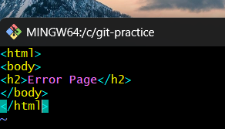

Step 2
Upload both files.
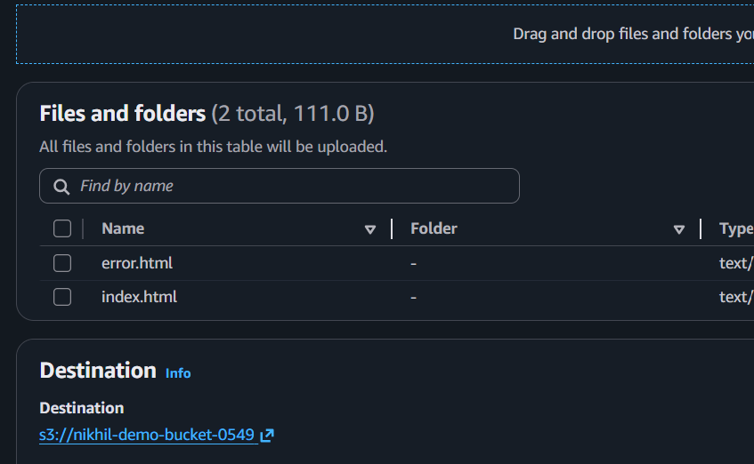
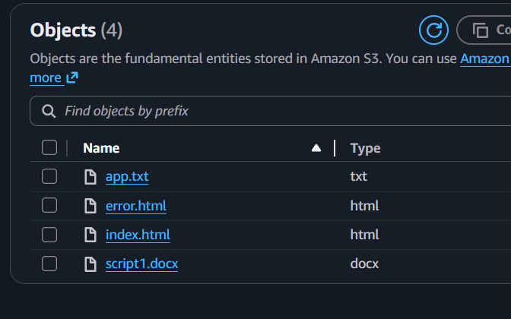

Step 3
Go to
Properties
↓
Static Website Hosting
↓
Enable
Document
index.html
Error Document
error.html
Save.
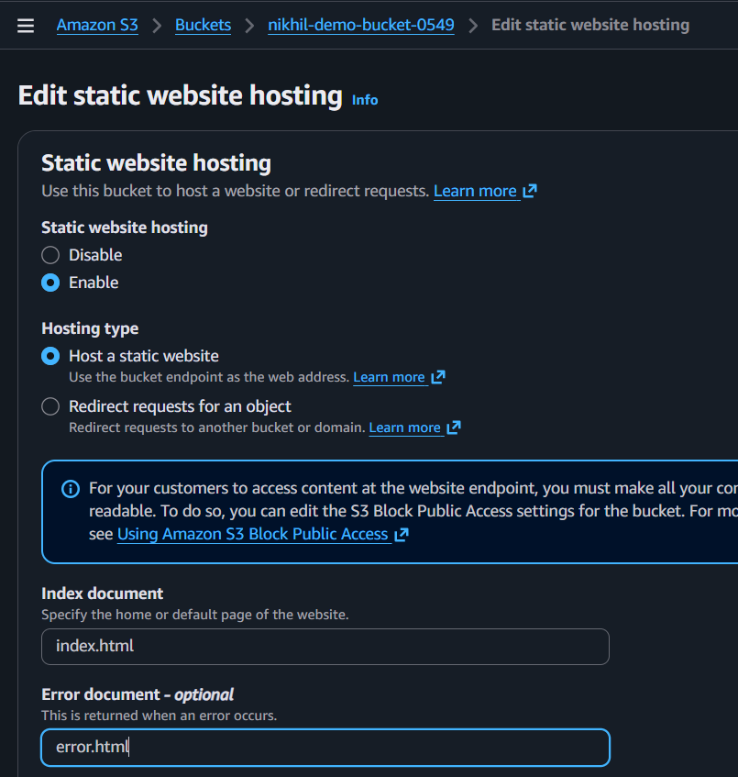
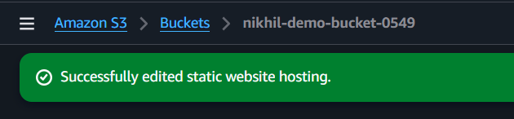

Step 4
Disable Block Public Access.
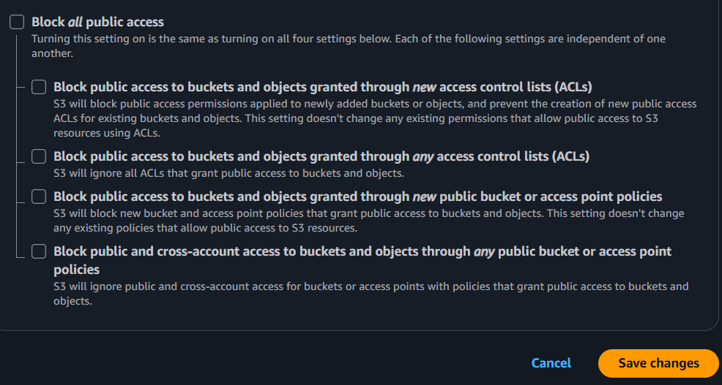

Step 5
Attach Bucket Policy
{
"Version":"2012-10-17",
"Statement":[
{
"Sid":"PublicRead",
"Effect":"Allow",
"Principal":"*",
"Action":"s3:GetObject",
"Resource":"arn:aws:s3:::YOUR_BUCKET_NAME/*"
}
]
}
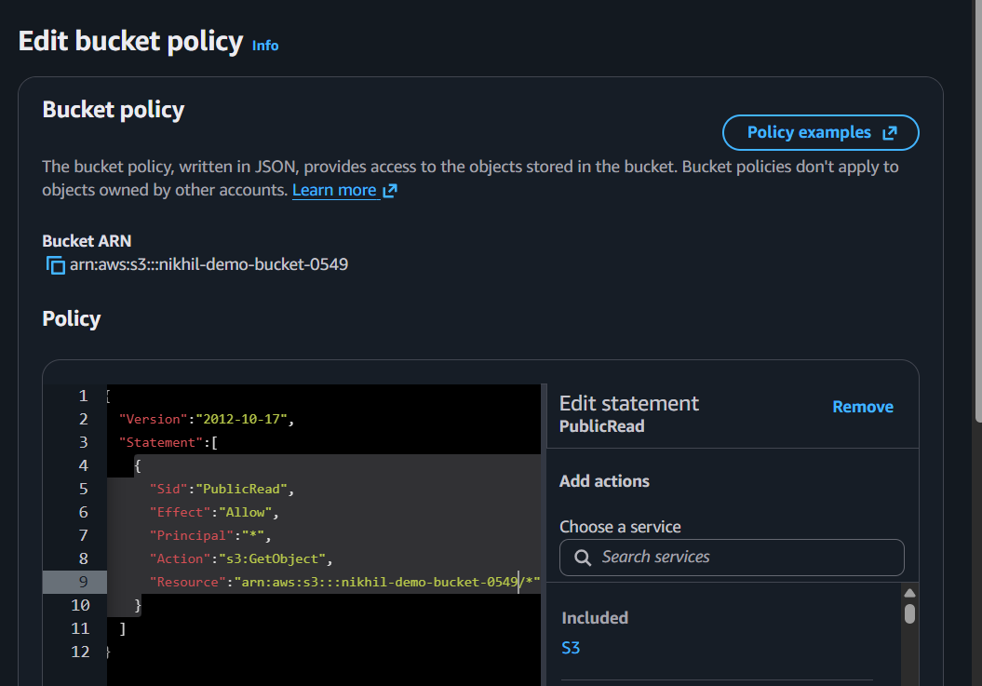.

Validation
Open
Bucket
↓

Properties

↓

Static Website URL
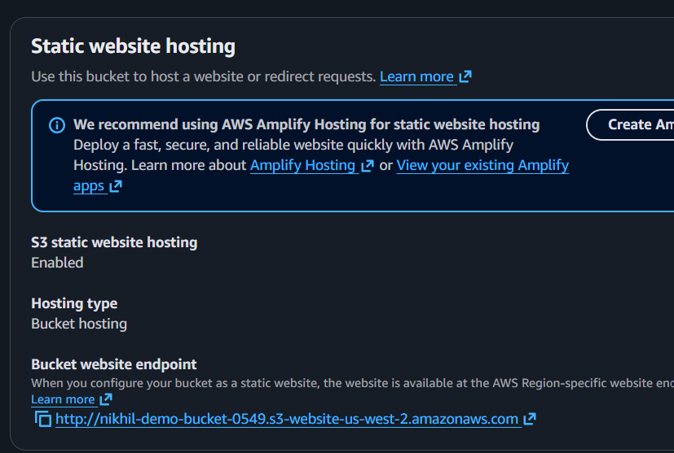
Open URL.
Expected Output
Welcome to My Website
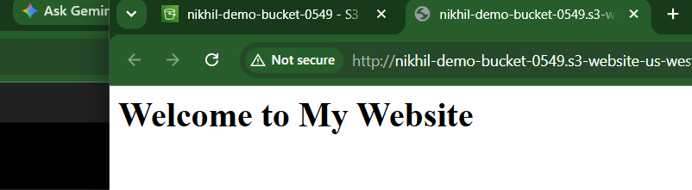

Task 3: Enable Cross Region Replication

Objective
Automatically replicate objects into another AWS Region.

Prerequisites
Need two buckets.
Example
Source
demo-source-bucket
Destination
demo-backup-bucket
Versioning must be enabled on both buckets.
IAM Replication Role.

Implementation Steps

Step 1
Create destination bucket in another Region.
Example
Oregon
Destination
Mumbai
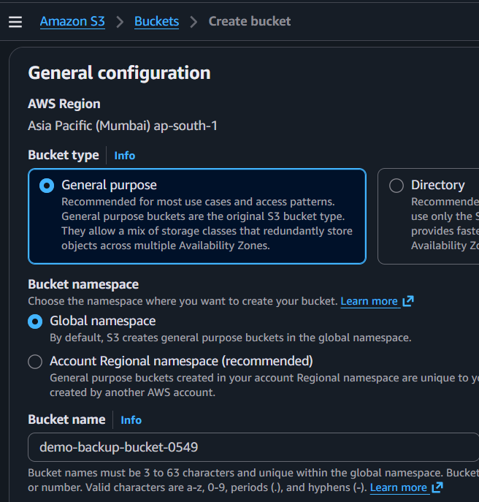

Step 2
Enable Versioning
Source Bucket
↓
Properties
↓
Versioning
↓
Enable
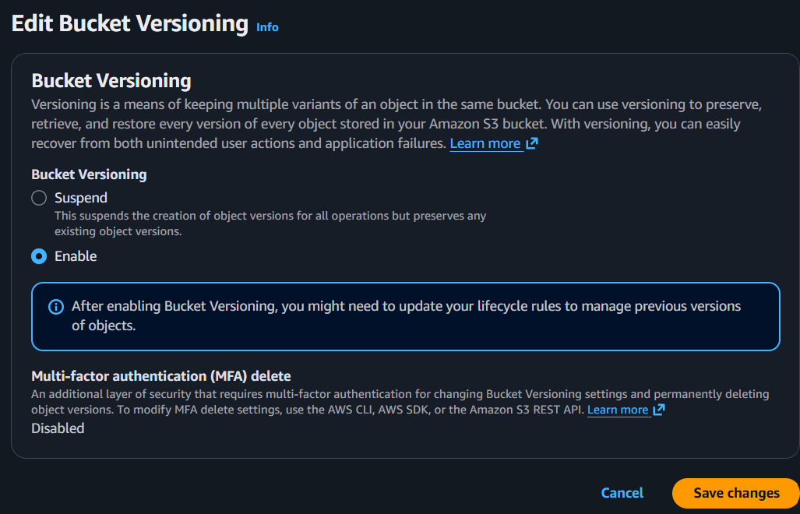
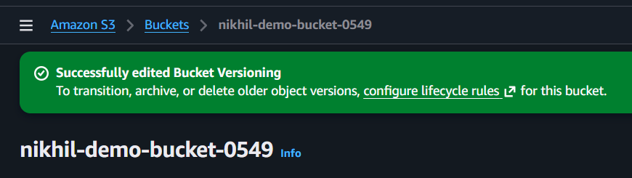
Repeat for destination.
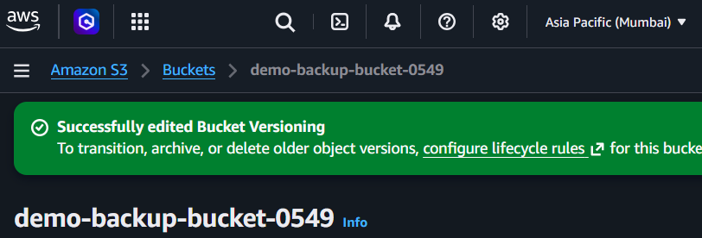

Step 3
Go to
Management
↓
Replication Rules
↓
Create Rule
Select
Entire Bucket
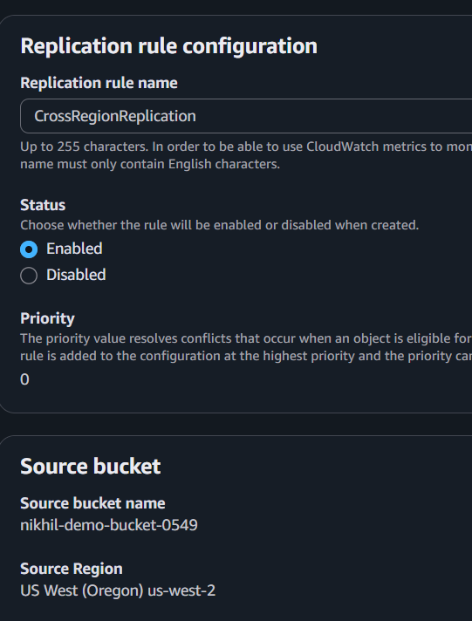

Step 4
Destination
Choose existing bucket
demo-backup-bucket
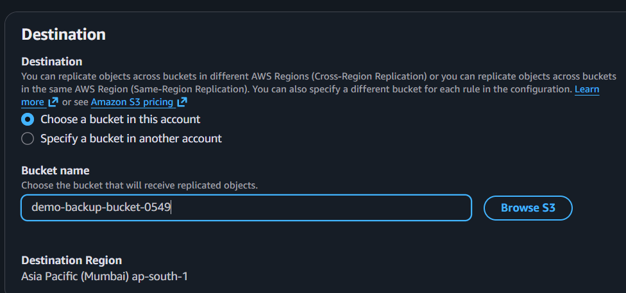

Step 5
Create IAM Replication Role automatically.
Save.
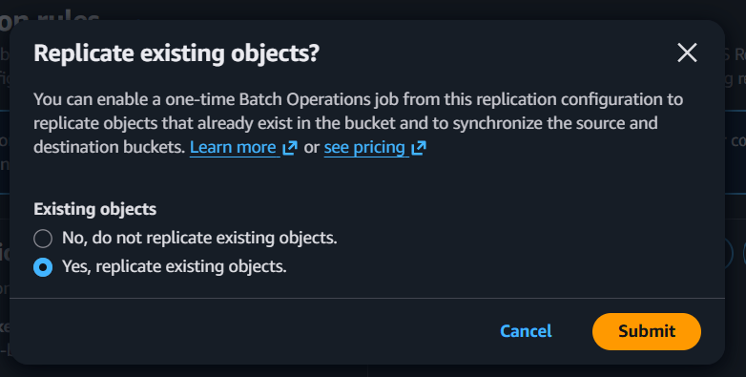

Step 6
Upload files into Source Bucket.
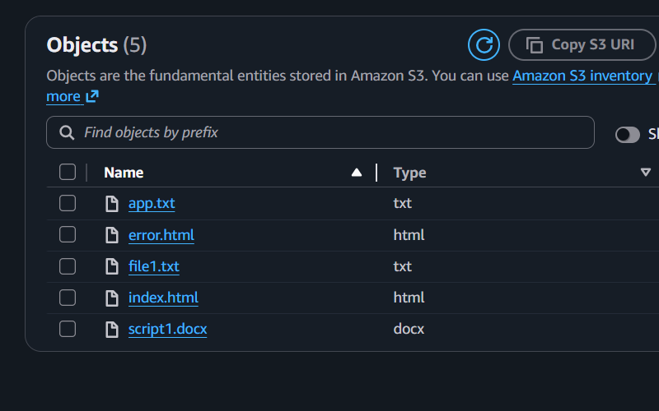

Validation
Wait 2-5 minutes.
Open destination bucket.
Verify uploaded files appear automatically.
Expected Result
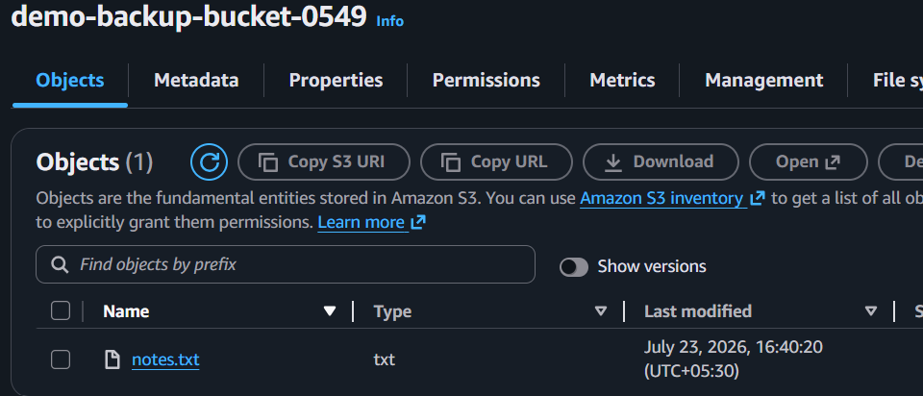

Task 4: Configure Bucket Policy so only User Can See Objects

Objective
Allow only one IAM user to access bucket objects.

Prerequisites
IAM User ARN.
Example
arn:aws:iam::123456789012:user/Admin
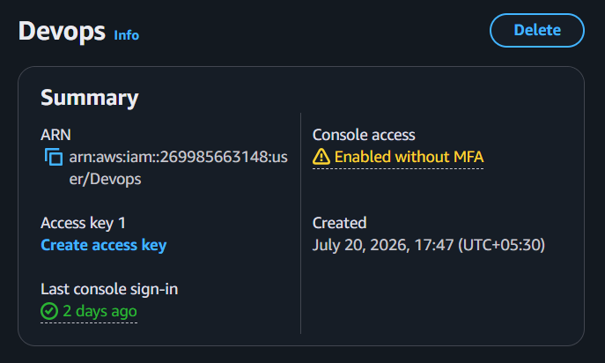

Implementation Steps
Go to
Bucket
↓
Permissions
↓
Bucket Policy
Paste
{
"Version":"2012-10-17",
"Statement":[
{
"Effect":"Allow",
"Principal":{
"AWS":"arn:aws:iam::123456789012:user/Devops"
},
"Action":"s3:*",
"Resource":[
"arn:aws:s3:::bucket-name",
"arn:aws:s3:::bucket-name/*"
]
}
]
}
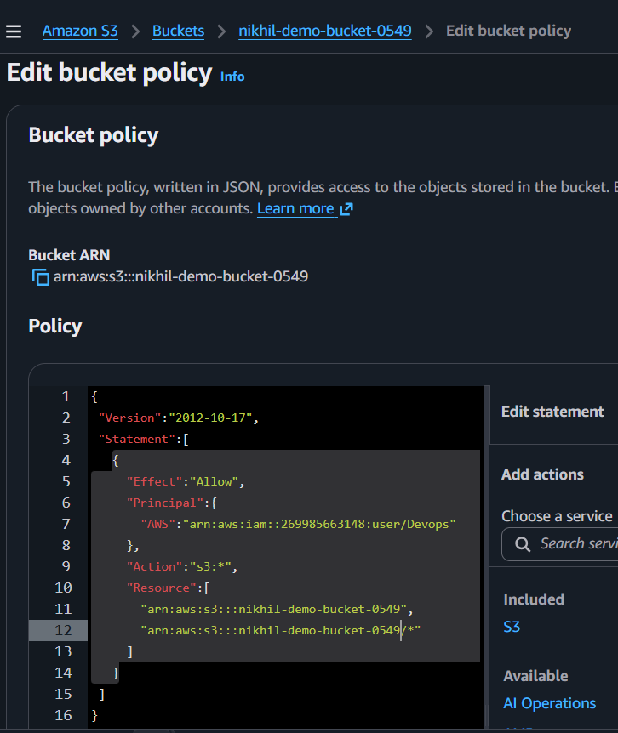Save.

Validation
Login using Devops user.
Open bucket.
Objects should be visible.
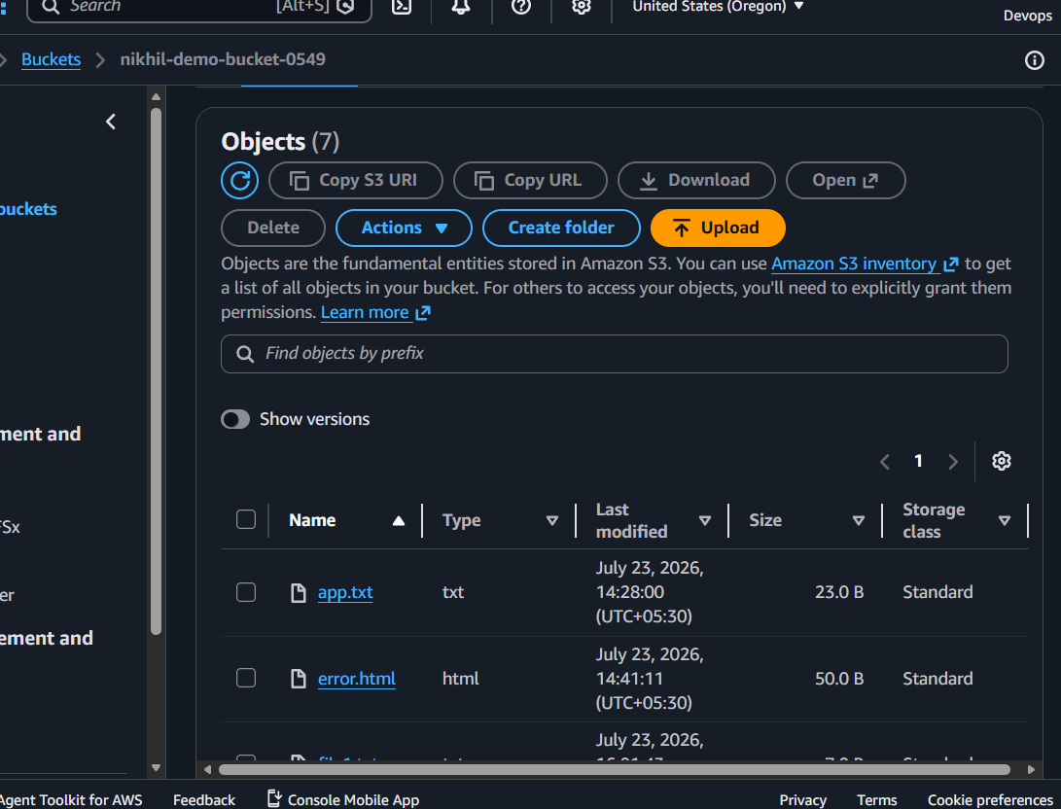
Login using another IAM user.
Expected
Access Denied
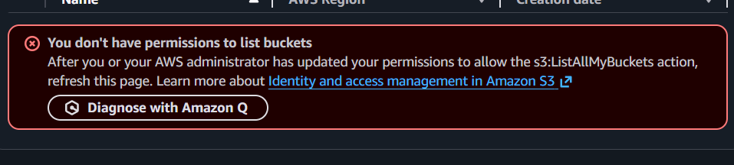

Task 5: Configure Lifecycle Policies

Objective
Automatically move objects to cheaper storage or delete them.

Prerequisites
Existing Bucket.
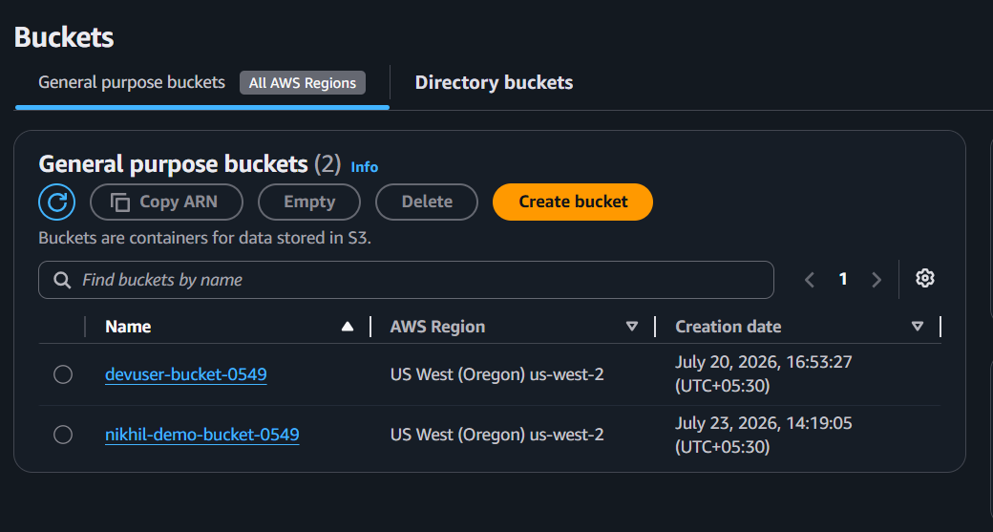

Implementation Steps
Go to
Management
↓
Lifecycle Rules
↓
Create Rule
Rule Name
DeleteOldFiles
Scope
Entire Bucket
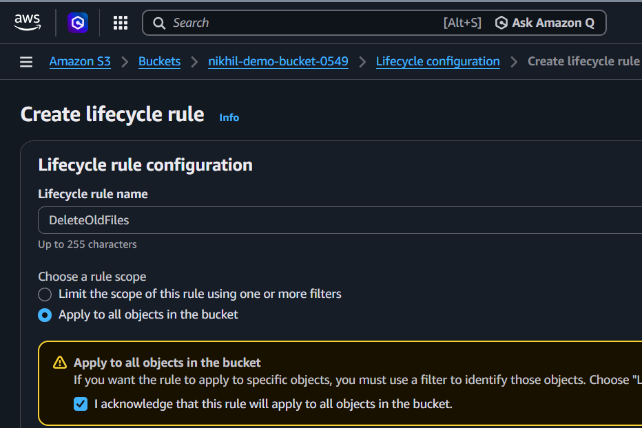
Actions
✓ Transition after 30 Days
↓
Standard IA
✓ Delete after 365 Days
Save.
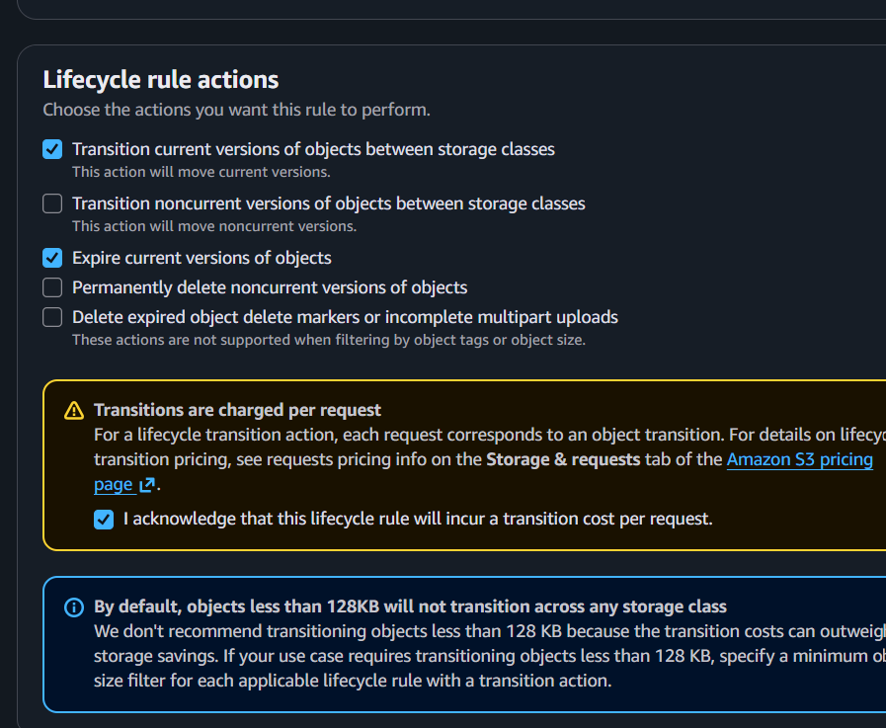
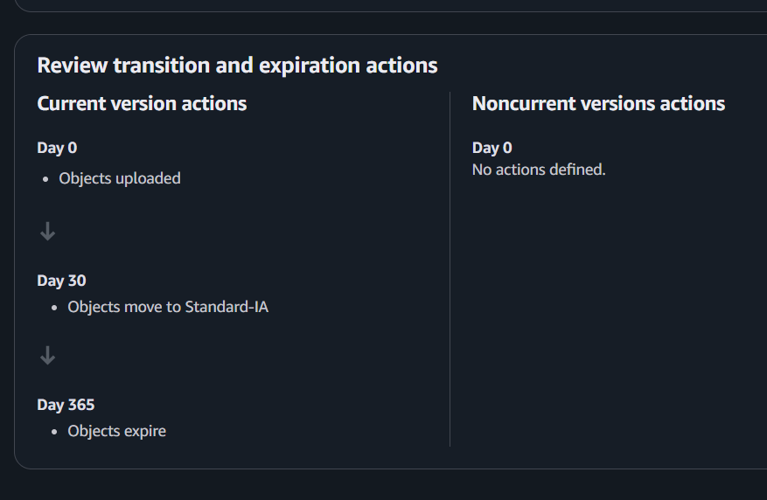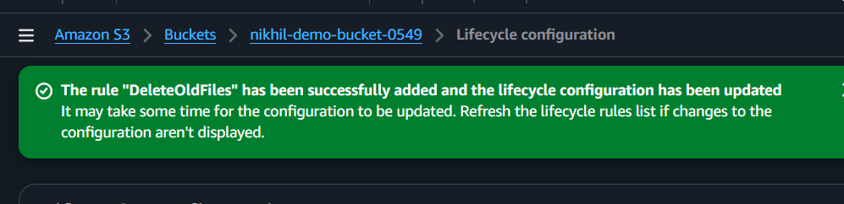

Validation
Open
Management
↓
Lifecycle Rules
Verify rule exists.
AWS automatically performs action after configured days.
Expected
Rule Status

Enabled
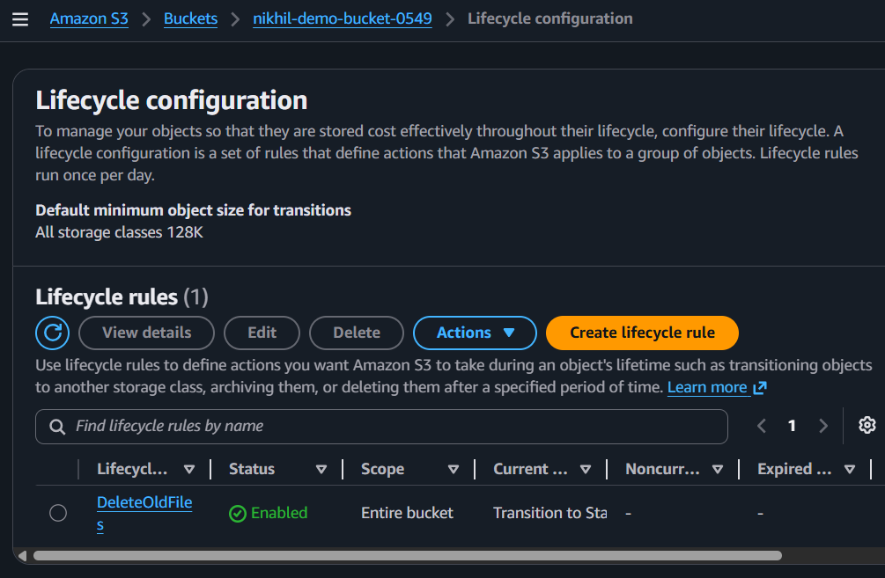

Task 6: Push Objects using AWS CLI

Objective
Upload files using CLI.

Prerequisites
AWS CLI installed.
Configure CLI
aws configure

Implementation
Upload single file
aws s3 cp file.txt s3://demo-bucket/
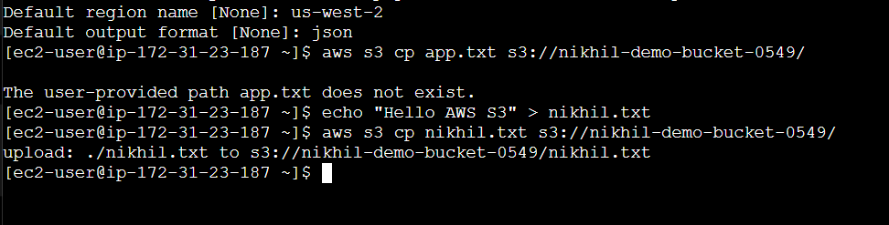

Validation
List objects
aws s3 ls s3://bucket-name
Expected the new file is available
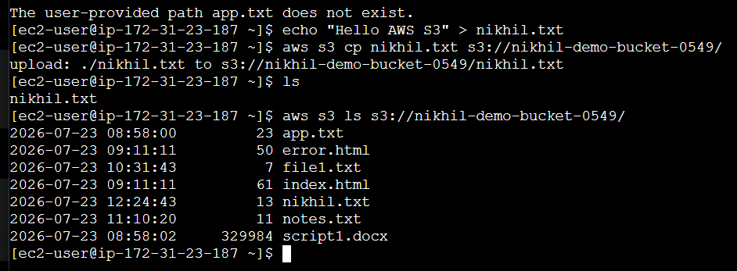
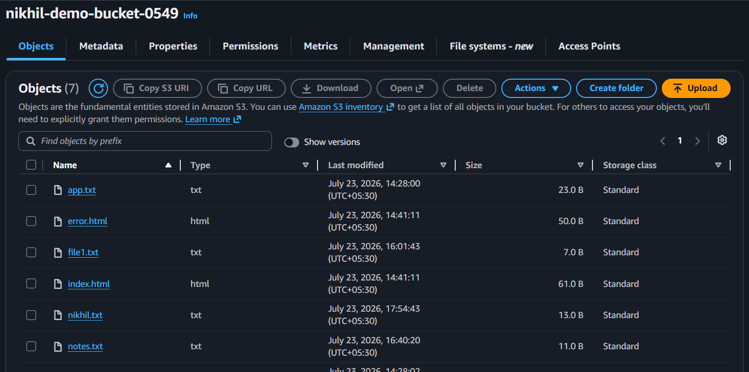

Task 7: Bash Script to Create an S3 Bucket

Objective
Automate bucket creation.

Implementation
Create
vi createbucket.sh
#!/bin/bash

BUCKET=my-demo-bucket-$(date +%s)
REGION=us-east-1

aws s3api create-bucket \
--bucket $BUCKET \
--region $REGION

echo "Bucket Created: $BUCKET"
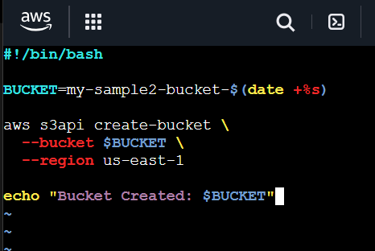
Permission
chmod +x createbucket.sh
Run
./createbucket.sh
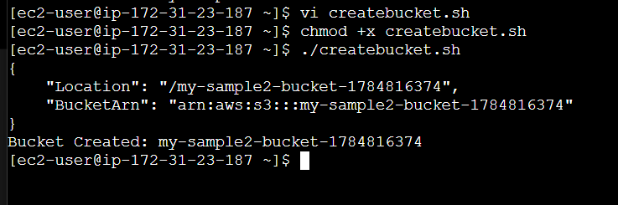

Validation
List buckets
aws s3 ls
Expected
2026-07-23
my-demo-bucket-1753264560
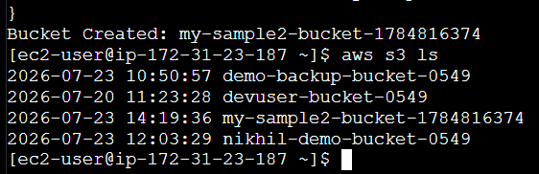
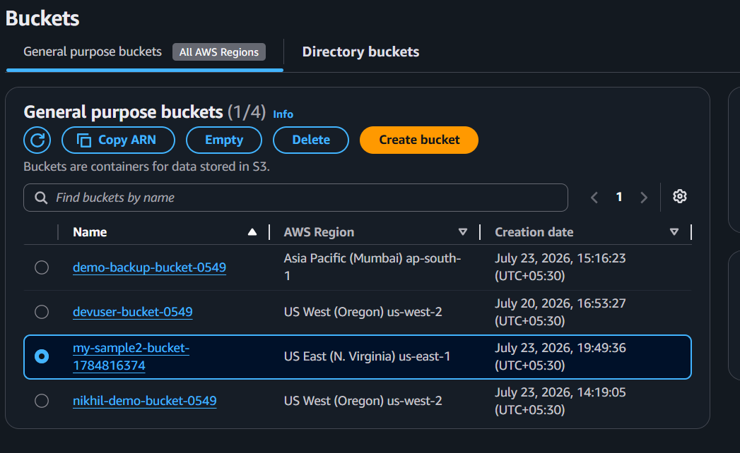

Task 8: Upload a 1 GB File using CLI

Objective
Practice large file upload.

Prerequisites
AWS CLI configured.
Bucket created.

Implementation
Step 1
Create a 1 GB file.
Linux
dd if=/dev/zero of=1GBfile.bin bs=1M count=1024
Check size
ls -lh 1GBfile.bin
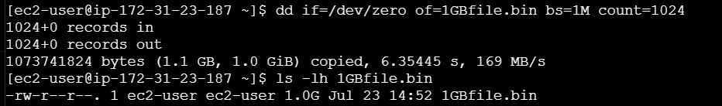

Step 2
Upload
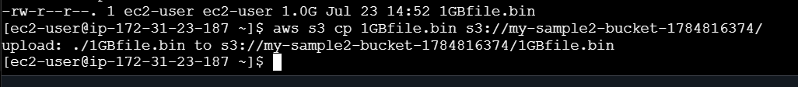
Monitor upload progress.

Validation
Verify object exists.
aws s3 ls s3://bucket-name/
Example output
2026-07-23 10:40:55 1073741824 1GBfile.bin
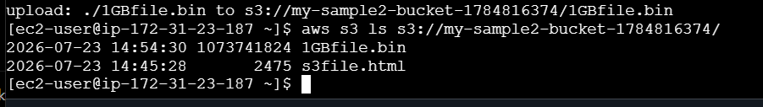
You can also verify from the AWS Console:
- Open the S3 bucket.
- Confirm 1GBfile.bin is listed.
- Check that its size is approximately 1.0 GB
